Morse Elementary supports community with food for summer

By Terry Oparka
65
Posted June 15, 2016
(Shutterstock image)
The Morse Elementary School community will address food scarcity in families that experience gaps in nutrition when students don’t eat breakfast and lunch at the school.
Forty percent of Morse Elementary School students receive free or reduced lunches through a federal program.
“It is simply too hard to sit by and watch kids and families be hungry,” Stephanie Zendler, principal of Morse Elementary School, said in a prepared statement. “There is a significant need, and we are eager and ready to reach out to them, with some help from our community friends.”
“This is the first year we are providing support for families in the summer,” Jen Hilzinger, who works as a paraprofessional at Morse Elementary School, said in an email. She is helping to spearhead the event.
“We have been providing food for hungry families for six years during the school year,” she said in the email. “We are looking forward to reaching hungry families this summer.”
The Morse community will come together this summer for Morse Summer Night, where families may exchange free summer reading books and take home fresh and canned food items, including fresh fruit, vegetables, dairy items and bread.
“We are looking for partners in our community who also care about eliminating summer gaps for these families,” Zendler said. “We’ve created some easy ways for community businesses and organizations to help families in need this summer.”
Morse Summer Nights will be held Wednesday evenings June 22-Aug. 24. Times will be announced.
For more information on Summer Nights or to sponsor a Summer Night event at Morse Elementary School, located at 475 Cherry Drive, call Zendler at (248) 823-3200.

Linden siblings create Snuggle Sacks for the needy
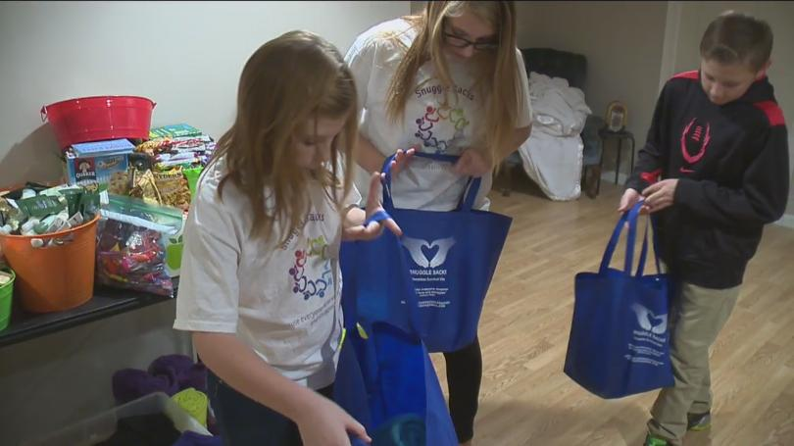
By Caresse Jackman |
Posted: Thu 11:42 PM, Dec 10, 2015 |
LINDEN (WJRT) - (12/10/15) - At 8 1/2 years old, Addisyn Goss is a hard working little lady. She's not spending her free time playing with dolls or watching TV. Nope, she's doing something much more selfless than that. Addisyn is helping the homeless.
" I feel good doing it," Addisyn said.
It started earlier this year, when Addisyn met her grandfather for the first time at a veterans home in Indiana, and learned the last few years have been rough for him.
" My grandpa Mike, we went to visit him a couple of months ago before school started and we figured out that he was homeless for about 6 years. I was like thinking it was sad, because he got his leg amputated too during that time. So, I just really felt bad for him," Addisyn said.
On the drive back home, she couldn't stop thinking about it and said to herself 'I've got to do something.' So, she came up with an awesome idea. Why not make a bag full of needy items for those who can't afford it. After brainstorming a little bit, she found the perfect name: Snuggle Sack.
" Because everyone deserves loves and snuggles," Addisyn said.
After creating a Snuggle Sack facebook page, the donations poured in, filling each blue bag up for those who go without.
" Blankets, gloves, hats, shampoo and conditioner, kleenex, hand warmers, and applesauce," Addisyn said.
It's a family affair too. Addy's older sister Sheridan and brother Jaxson are part of the Snuggle Sack crew.
" It's incredible that my sister, younger than me, can come up with that and go through with it. And it just makes me really proud," Sheridan said.
After Addy and her siblings place deodorant, scarves and gloves inside the bags, they also do something very special too. They place a Word of Hope, a little message, letting those receiving the sack know that while they're going through hard times, there are people out there who do care about them.
Two weeks ago, they traveled to Flint and gave away 50 Snuggle Sacks to those who needed them most.
" We passed them out at the North End Soup Kitchen in Flint. They said thank you, and some of them gave me hugs," Addisyn said.
Their mother, Stacy Daul, is so honored her little angels are taking it upon themselves to help their fellow neighbor.
" I stood in the corner at the soup kitchen, just, in tears. To see that my kids, really genuinely just want to keep doing it. They love it. They get home and see something on the porch, they're excited! And I think especially, with the holidays coming up, it just puts so much in perspective for us," Stacy Daul said.
The siblings plan on passing out 50 more sacks on December 19th to Carriage Town Ministries in Flint.
High Octane Designs in Fenton is a sponsor. Costco is in the process of giving the kids a membership, and more sponsorship opportunities may come.
The kids are looking forward to getting non-profit status.

Metro Detroit "Invisible Dad" ensures all elementary students get lunch
Kim Russell 5:32 PM, Apr 28, 2017
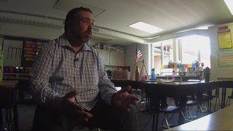
WALLED LAKE, Mich. (WXYZ) - This is a story that started when one dad asked a question so many parents ask their children every day: How was school today? What his little girl had to say broke his heart.
It had to do with lunch. She said her friend didn’t sit by her that day.
“Why didn’t you sit with your friend at lunch? She said she got cheese and crackers that day,” said Tony Casanova.
He found out his daughter’s friend’s parents struggled. They didn’t always have enough to buy their daughter lunch. When children didn’t have lunch money, the school gave them cheese and crackers. It had changed the little girl’s routine, so she didn’t sit by his daughter as she usually did.
For Tony, it brought back memories. His single mom didn’t have money for his lunch at times growing up. He remembered being given a snack set aside for such circumstances. He knows how children feel in this situation.
“He is marked as different because he got that different lunch that is handed out,” said Tony.
He started doing research. He found out children who don’t get lunch are more likely to drop out of school. He says he understands why. He got a job to help his family and didn’t feel like he fit in at school.
“It impacts whether or not a child graduates. That is what the statistics absolutely say, and that in a nutshell is my story.”
Tony says the school and government have great programs in place, such as free and reduced lunches, but some kids fall through the cracks.
“Sometimes our parents are prideful or are on that border where they can’t get free and reduced lunch but they still need help,” said Julie Rader, Food Service Supervisor at Walled Lake Consolidated Schools.
“Every kid deserves lunch no matter what,” said Tony.
He stepped up. He asked to start what he calls the Invisible Dad Account. He donated money to buy lunches, so no child goes without a nutritious meal.
“I am not a rich man. I am a janitor. I clean toilets and after cleaning the toilets, I take a little bit of money because it is more important that a child eats a lunch at school than I have a unicorn latte,” said Tony
“If there isn’t money for lunch, it isn’t a child’s problem. It is an adult problem,” said Marcy Augenstein, Ph.D, Keith Elementary School Principal.
Tony has remained invisible, donating behind the scenes, until now. He is sharing his story to inspire others.
The Walled Lake Consolidated Schools is working to put an “Invisible Dad” program in all elementary schools. Tony helps parents across the country do what he did. Go to their child’s school, and volunteer to donate to make sure every child has a lunch.
Tony says he hopes this effort sends a message to children who need help getting lunch.
“You are totally worth it,” he says.
Copyright 2017 Scripps Media, Inc. All rights reserved. This material may not be published, broadcast, rewritten, or redistributed.

Detroit Teen Builds Libraries and Friendships While Helping His Community’s Homeless
BY CATHY FREE•@CATHYJFREE
POSTED ON NOVEMBER 17, 2016 AT 10:18AM EDT
Caleb White was six years old the first time he saw a homeless person sleeping on a sidewalk on a winter’s night in downtown Detroit.
“Mama, why is that man sleeping outside in the cold?” he asked his mother, Melissa Kennedy, after they attended a circus one weekend. “Why doesn’t he sleep in a bed?”
When Melissa told him that some people didn’t have homes to sleep in, Caleb burst into tears.
“We need to build him a house — we need to help him,” he said.
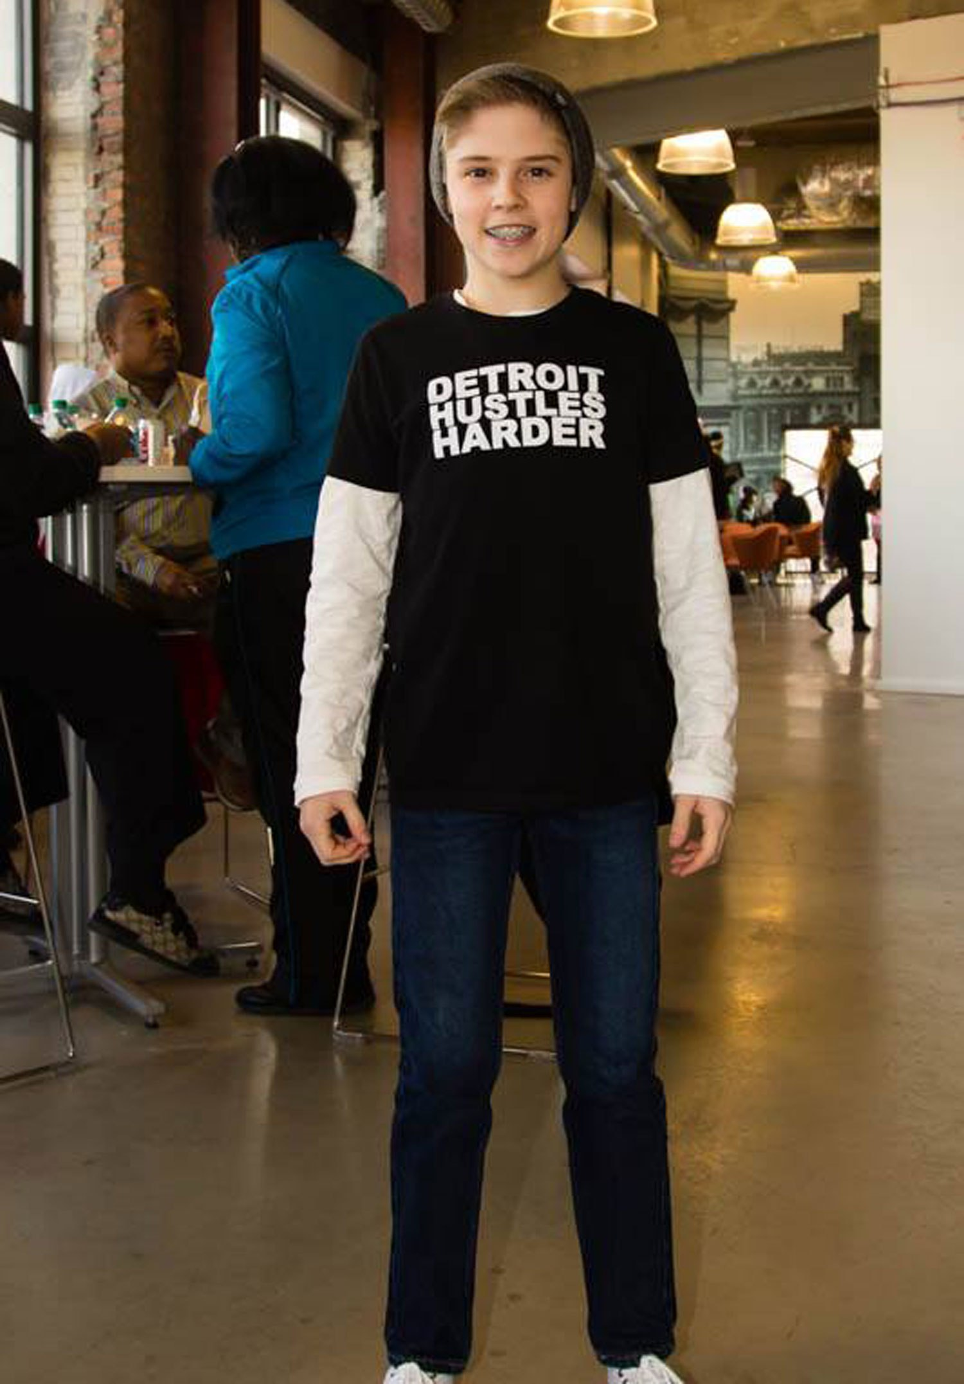
Not wanting to let the moment pass, Melissa asked her son if there were other ways they might be able to help.
“Caleb went home and asked family and friends to bring donations of hand warmers, gloves and socks to help people through the winter,” she tells PEOPLE. “He has such a tender heart — I knew there was something special going on. He’s a humble, good kid.”
That small moment on a chilly night seven years ago has now become a community-wide effort to help Detroit’s homeless through the Caleb White Project , a nonprofit run by Caleb, now 14, and Annette, a single mother and marketing creative director with one other son, Noah, 8.
The charity donates backpacks full of school supplies to children in need, holds Christmas parties for homeless veterans and game nights for kids, donates hundreds of boxes of warm clothing in winter months and has opened small libraries in all 10 of Detroit’s homeless shelters to “give people a place to escape for a while,” says Caleb.
“At home, I have a lot of books, and I noticed that the people we were helping usually didn’t have any,” the Detroit Catholic Central High School ninth-grader tells PEOPLE. “Most people living in a shelter don’t have a place to go outside their tiny room. It feels good to know they now have a place where they can find a good book and forget about their problems for a while.”
Caleb’s library project brought 3,000 Detroit youths together last April to turn one room in each city shelter into a reading room filled with shelves of donated books, bright lighting, cozy chairs, new floors and colorful art for freshly-painted walls.
“The benefits of Caleb White’s library project to the men, women and children we rescue and rehabilitate in metro Detroit speak volumes of his benevolent heart and commendable vision,” Chad Audi, president and CEO of the 107-year-old Detroit Rescue Mission Ministries, tells PEOPLE. “We deeply appreciate and hold him up as a young exemplar of compassion in our community.”
And the kids love it, too.
“You need to have seen – during last school break – the excitement on the faces of kids at our Genesis House 2 and Genesis House 3 facilities each time they opened the library books and read to the delight of their mothers and our kid-friendly staff,” he says. “That was such a priceless feeling.”
Adds Michael Cuttler, outreach manager for Youth Service America: “While Caleb has an uncanny ability to mobilize others, the most incredible thing about him is his awareness and humble approach to complex societal problems like hunger, education and homelessness at such a young age.
“He has demonstrated wisdom beyond his years,” Cuttler, whose group gave Caleb’s nonprofit a $1,000 grant to help furnish the libraries, tells PEOPLE. “For a city that has faced so many challenges, Caleb is truly a white knight, showing how promising the future can be if a few more people just think and act the way he does.”
Caleb, who regularly recruits students from area schools to help with his projects, says that the joy of witnessing “small moments” is what keeps him going.
“Homelessness is something that could happen to anyone – most people didn’t choose to live this way,” he says. “They had something happen in their lives that was catastrophic. You don’t have to do something big to make a difference. Even giving somebody a pair of gloves can brighten up their day.”
Caleb’s favorite project is something he calls “game night,” when his mom takes him and a group of friends to a family shelter on a Saturday evening to play board games and have snacks with young residents.
“They’re just like us — they like to hang out and have fun and laugh,” he tells PEOPLE. “I’ve made some great friends there.”
“Caleb realized early on that there was a disconnect if you don’t come down here and actually spend time with the people you’re trying to help,” says Melissa. “He’s helped open my eyes, too, so I like to say that there’s a lesson in my son’s generous spirit for all of us: If he could do this at age 6, then anybody can.”

