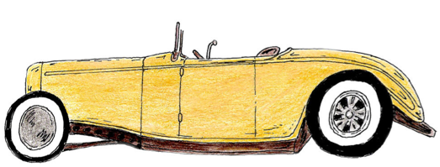
THE GREAT GATSBY
Presentations

“…He had a grand vision for his life since he was a boy… No amount of FIRE could change the FAIRYTALE he had stored up in his HEART … But I had the uneasy feeling that he was guarding secrets.”

Students, in groups of 4-5, will investigate who was ultimately “responsible” for the death of Jay Gatsby. Students will track their character’s development within the novel, considering their motivations, what is driving their “American Dream,” and relationships with other characters. Their findings must be presented with textual evidence in a courtroom closing argument format.

Students will be divided into 6 Groups based on the main characters in the novel:
• Nick Carraway
• Daisy Buchanan
• Jay Gatsby (himself)
• Tom Buchanan
• George Wilson and/or Myrtle Wilson
• Society

Students will create a multi-media presentation to support their oral argument in which they will present their case to the class why their character is ultimately responsible for the death of Jay Gatsby. Their presentations must include a form of media: graphics, images, videos, music, etc. Presentations will be in the format of a courtroom closing arguments. The jurors will be outside peers to provide an unbiased verdict.

REQUIREMENTS:
- Open Argument = Thesis
- Minimum of 3-5 points to support your claim
- Minimum of 3-5 quotes of text
- Presentation should be 4-5 minutes
- Visual needs to grade-level appropriate (No Prezi)
- 2 presenters per group and 2-3 researchers and visual artists

The jury will decide and the best argument will be revealed.
PROJECT DUE DATE: __________________________

