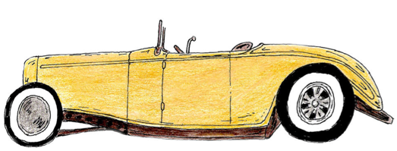
The Great Gatsby Character Tracking

“So we beat on, boats against the current, borne back ceaselessly into the past”

Assigned Character Responsible for Gatsby’s Death: __________________________________
Group Members: ______________________________________________________________

Throughout the book, track your character’s development within the novel that may lead them to be responsible for Gatsby’s death: their motivations, their “American Dream” and what is driving it, their growth, their interactions/relationships with other characters, etc.

Character Observations (motivations, their “American Dream,” interactions, etc.) | Supporting Quotes (if applicable)  *Note: if you have a page number, you can just copy the first few words of the quote so it is easy to locate later | Pg. #

Notes: “A-ha” moments causing you to believe this character is responsible for Gatsby’s death

