Goodreads Reading Community – Instruction Sheet

- Access Goodreads Group: Log in to Schoology and click on the link for your hour's Goodreads group
  - Clicking on the link will add you to the group automatically

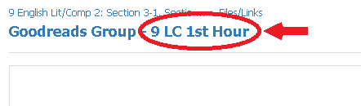

- Log-In to Goodreads: If you already have a Goodreads account, log in; if you do not have an account, you have to create one
  - It will ask you for your name, your email, and a password...please use an email that you have access to and know the password to (password can be anything that you will remember)

- Verify your Email: Once you have created an account, the FIRST thing you need to do is verify your email
  - Go to the email address you used for your account, open the email from Goodreads, and then click on "Verify Email". You are now ready to begin!

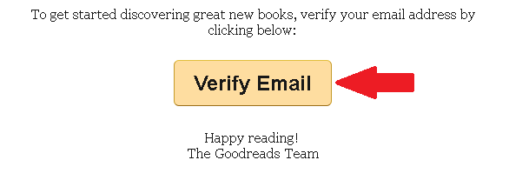

- NOTE: If you do not receive the email, go to your email and check your “Social” folder or your junk/spam folder. If there is nothing from Goodreads, add no-reply@mail.goodreads.com to your email contacts to unblock the email

- NOTE: If you still do not receive the email, go to your Goodreads profile (click on your profile picture in the top right corner, and then click "Account Settings" on the drop-down menu), then make sure the email in the box is correct, and then resend the email (you may want to try a different email if the first one doesn't work)

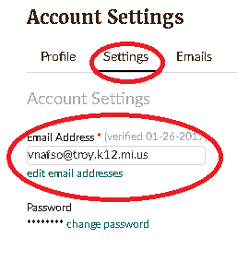
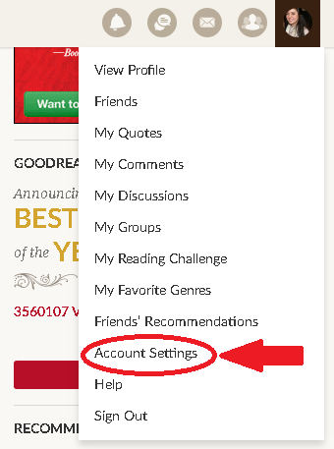

- Answer Discussion Question: Once your email is verified, click on the "discussion" button on the top right corner, then click on the discussion "What is your current attitude about reading?" Post your answer by scrolling to the end of the page and writing your response in the comment box.

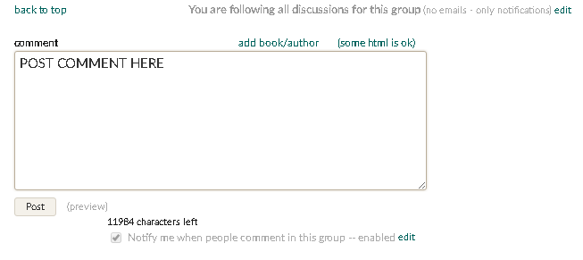

- Respond to 2 Classmates' Posts: Once you post your own response, respond to two classmates' posts by hitting reply and then typing your response below the copied text in the comment box.
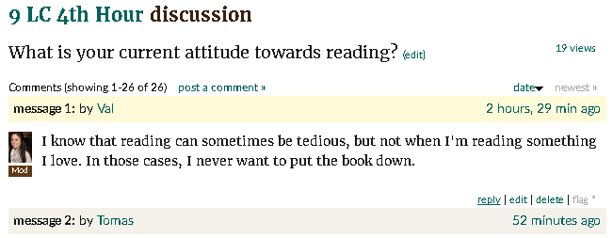

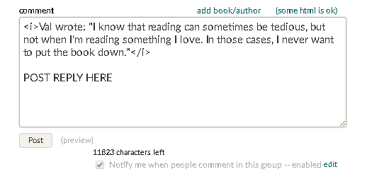

- Build your Goodreads Profile
  - Adjust settings to what you prefer (email notifications, privacy, etc.)

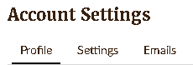
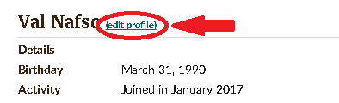

  - Upload a profile picture (does not have to be of you...it can be a picture of something from google images)

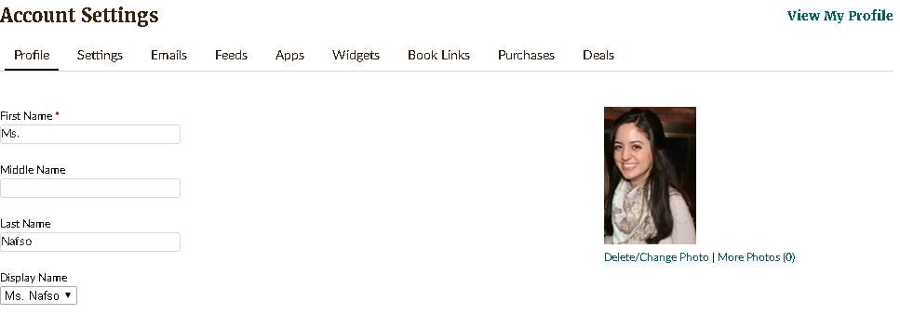

  - Choose the genres you're interested in to allow Goodreads to give you recommended titles (you can edit your genres in the "Explore" tab)

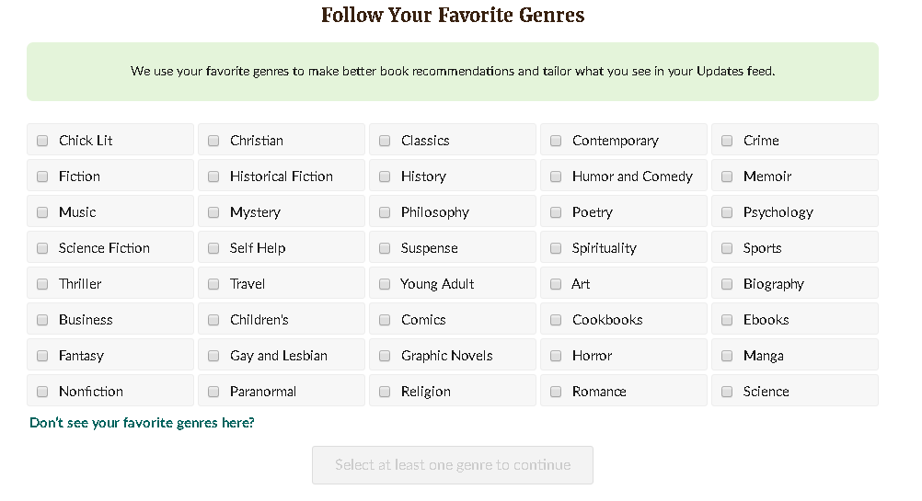

- Explore Goodreads
  - 2017 Reading Challenge: Set a realistic, yet challenging goal (ex: my minimum is a book a month, which makes my challenge 12 books)

  - Update "Currently Reading" with a book you're reading right now IF you are reading one (search the book, choose "Currently Reading" in green drop down menu next to the book)
  - Update "Books Read" with all the books you have read this school year so far, starting with your summer reading book (search the book, choose "Read" in the green drop down menu next to the book)
    - It will ask you to rate those books...rate them so that Goodreads can start recommending books for you based on your ratings of the books you have read
  - Update "Want to Read" with 5 books you want to read by the end of the school year (search the book, choose "To Read" in green drop down menu next to the book)
    - You can find books you want to read through the "Explore" tab. Explore, read reviews, check ratings, etc.
