Name ____________________________________________________ Hour _____________
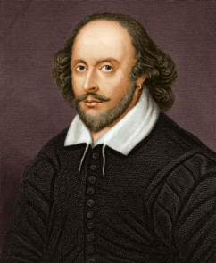
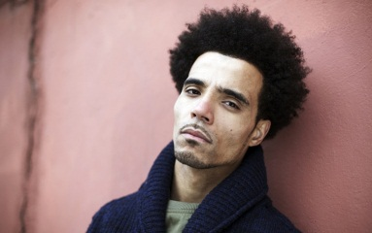
Hip Hop and Shakespeare?
Akala TED Talk

- “To destroy the beauty from which one came.”
  - Shakespeare
  - Hip Hop

- “Maybe it’s hatred I spew. Maybe it’s food for the spirit.”
  - Shakespeare
  - Hip Hop

- “Men would rather use their broken weapons than their bare hands.”
  - Shakespeare
  - Hip Hop

- “I was not born under a rhyming planet.”
  - Shakespeare
  - Hip Hop

- “The most benevolent king communicates through your dreams.”
  - Shakespeare
  - Hip Hop

- “Socrates, philosophies, and hypotheses can’t define.”
  - Shakespeare
  - Hip Hop

- What does your heartbeat have to do with an iamb?

- What does tonality have to do with all of this?

- Tell me about mood/blood, hours, chasm between rich/poor:

- Over ____ % of Shakespeare’s audience could neither read nor write.

- When Akala explains the following words, show me your thinking about them below:

Hip Hop

- Are you a custodian of knowledge? Am I? What kind of responsibilities do you think we have?

- What is the purpose of education: to whom does it belong, and to whom does it not belong?

- The goal of both hip hop and Shakespeare is to…

