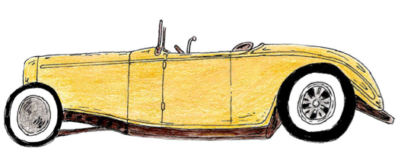
The Great Gatsby
KILLER PRESENTATION PLAN

Plan your group’s reasons for why your character is MOST responsible for Gatsby’s death. Consider your character’s development, their motivations, their “American Dream” and what is driving it, their growth, their interactions/relationships with other characters, etc.

REASON #1:

Character Observations (motivations, their “American Dream,” interactions, etc.):

Possible ideas for evidence to create for visual support:

REASON #2:

Character Observations (motivations, their “American Dream,” interactions, etc.):

Possible ideas for evidence to create for visual support:

REASON #3:

Character Observations (motivations, their “American Dream,” interactions, etc.):

Possible ideas for evidence to create for visual support:

