Unit 9.2: Hero’s Journey Literature Circles
Review the descriptions below and create a list of books that you are interested in and that you have not already read. There is a limited number of each book available, so make sure you have a list of at least three books that interest you, as you may not get your first choice. Feel free to browse reviews on Amazon or GoodReads to see what others have to say about the books.
BOOK COVER | BOOK TITLE & GENRE | AUTHOR | BRIEF SYNOPSIS
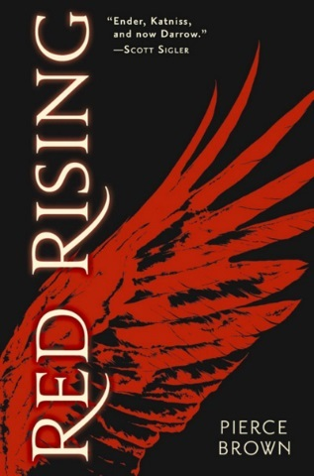 | Red Rising  (Dystopian/Science Fiction) | Pierce Brown | Darrow is a Red, a member of the lowest caste in the color-coded society of the future. Like his fellow Reds, he works all day, believing that he and his people are making the surface of Mars livable for future generations. Yet he spends his life willingly, knowing that his blood and sweat will one day result in a better world for his children.  But Darrow and his kind have been betrayed. Soon he discovers that humanity reached the surface generations ago. Vast cities and lush wilds spread across the planet. Darrow—and Reds like him—are nothing more than slaves to a decadent ruling class.
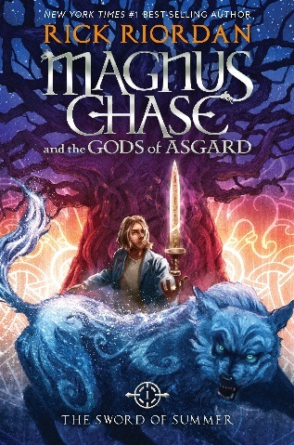 | Magnus Chase and the Gods of Asgard: The Sword of Summer  (Fantasy) | Rick Riordan | Magnus Chase has always been a troubled kid. Since his mother's mysterious death, he's lived alone on the streets of Boston, surviving by his wits, keeping one step ahead of the police and the truant officers.  One day, he's tracked down by an uncle he barely knows-a man his mother claimed was dangerous. Uncle Randolph tells him an impossible secret: Magnus is the son of a Norse god
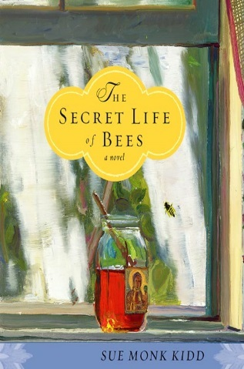 | The Secret Life of Bees  (Historical Fiction) | Sue Monk Kidd | Set in South Carolina in 1964, The Secret Life of Bees tells the story of Lily Owens, whose life has been shaped around the blurred memory of the afternoon her mother was killed. When Lily's fierce-hearted black "stand-in mother," Rosaleen, insults three of the deepest racists in town, Lily decides to spring them both free. They escape to Tiburon, South Carolina--a town that holds the secret to her mother's past. Taken in by an eccentric trio of black beekeeping sister, Lily is introduced to their mesmerizing world of bees and honey, and the Black Madonna.

BOOK COVER | BOOK TITLE & GENRE | AUTHOR | BRIEF SYNOPSIS
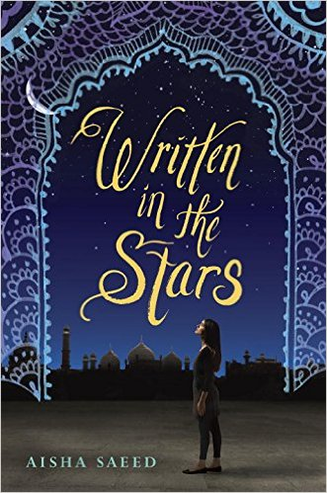 | Written in the Stars  (Realistic Fiction) | Aisha Saeed | Naila’s conservative immigrant parents have always said the same thing: She may choose what to study, how to wear her hair, and what to be when she grows up—but they will choose her husband. Following their cultural tradition, they will plan an arranged marriage for her. And until then, dating—even friendship with a boy—is forbidden. When Naila breaks their rule by falling in love with Saif, her parents are livid. Convinced she has forgotten who she truly is, they travel to Pakistan to visit relatives and explore their roots. But Naila’s vacation turns into a nightmare when she learns that plans have changed—her parents have found her a husband and they want her to marry him, now!
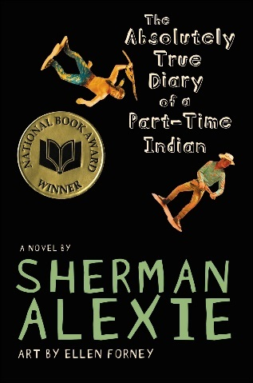 | The Absolutely True Diary of a Part-Time Indian  (Realistic Fiction) | Sherman Alexie | Bestselling author Sherman Alexie tells the story of Junior, a budding cartoonist growing up on the Spokane Indian Reservation. Determined to take his future into his own hands, Junior leaves his troubled school on the rez to attend an all-white farm town high school where the only other Indian is the school mascot.
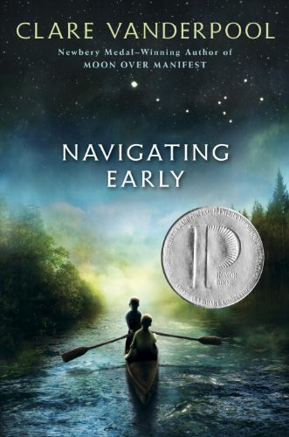 | Navigating Early  (Historical Fiction) | Clare Vanderpool | When Jack Baker’s father sends him from his home in Kansas to attend a boys’ boarding school in Maine, Jack doesn’t know what to expect. Certainly not Early Auden, the strangest of boys. Early keeps to himself, reads the number pi as a story, and refuses to accept truths others take for granted. Jack, feeling lonely and out of place, connects with Early, and the two become friends.  During a break from school, the boys set out for the Appalachian Trail on a quest for a great black bear. As Jack and Early travel deeper into the mountains, they meet peculiar and dangerous characters, and they make some shocking discoveries. But their adventure is only just beginning. Will Jack’s and Early’s friendship last the journey? Can the boys make it home alive?

BOOK COVER | BOOK TITLE & GENRE | AUTHOR | BRIEF SYNOPSIS
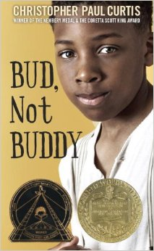 | Bud, Not Buddy  (Historical Fiction) | Christopher Paul Curtis | It’s 1936, in Flint Michigan. Times may be hard, and ten-year-old Bud may be a motherless boy on the run, but Bud’s got a few things going for him:  1. He has his own suitcase full of special things.  2. He’s the author of Bud Caldwell’s Rules and Things for Having a Funner Life and Making a Better Liar Out of Yourself.  3. His momma never told him who his father was, but she left a clue: flyers advertising Herman E. Calloway and his famous band, the Dusky Devastators of the Depression!!!!!!  Bud’s got an idea that those flyers will lead him to his father. Once he decides to hit the road to find this mystery man, nothing can stop him—not hunger, not fear, not vampires, not even Herman E. Calloway himself.
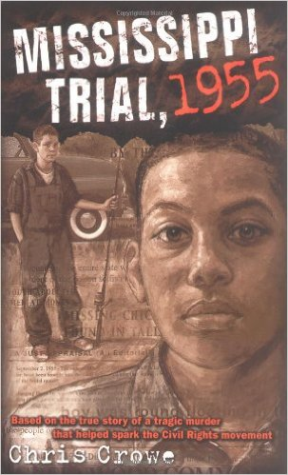 | Mississippi Trial, 1955  (Historical Fiction) | Chris Crowe | A historical fiction novel about the abduction and murder of Emmett Till in Greenwood, Mississippi. The narrative portrays the racism that plagues the south in the Civil Rights Era through the fictional story of a young white boy named Hiram Hillburn and his friendship with Till.
 | Flowers for Algernon  (Science Fiction) | Daniel Keyes | A mentally challenged man receives an operation that turns him into a genius...and introduces him to heartache.

