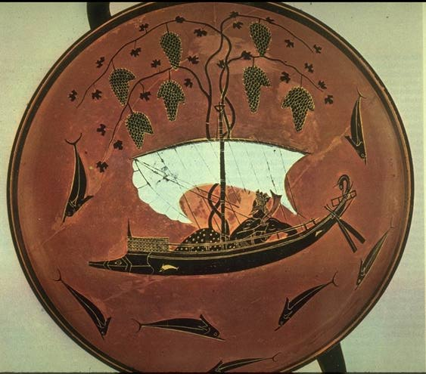
Book 1: The Wanderings of Odysseus (pgs. 1104-1105)
After your initial reading, return to the text to complete the questions and graphic organizers below.

1. Who is Homer asking to help him tell the story of Odysseus?

2. This invocation in lines 1-15 introduces us to Odysseus, “that man skilled in all ways of contending.” What traits is this epic hero shown to have?
Evidence from text (QUOTE) | Inference/Explanation (SHOWS)
a.

b.

c.

d.

Book 9: New Coasts and Poseidon’s Son (pgs. 1110-1123)
After your initial reading, return to the text to complete the questions and graphic organizers below.
“I AM LAERTES’ SON”
- As Odysseus introduces himself to King Alcinous and begins to share his adventures, what do we learn about Odysseus’ values?

- What is the tone of this passage? What emotions is Odysseus portraying?

“THE LOTUS EATERS”
- Describe the internal conflict Odysseus and his men encounter in the land of the Lotus Eaters.

“THE CYCLOPS”
- What is the purpose of Odysseus alluding to Zeus and Agamemnon when he first comes in contact with the Cyclops? How does the Cyclops respond?

- Describe three strategies that the wily Odysseus uses to outwit Polyphemus.

- What curse concludes the Cyclops adventure—foreshadowing trouble ahead for Odysseus?

- Quote an example of an epic simile from Book 9. Explain why it is an epic simile.

5. On page 1113, lines 91-92, what does the metaphor imply about the Cyclops?

6. It is important to remember, as we listen to Odysseus’ adventures, that the Odyssey was used as part of Greek children’s education for centuries after the poem was written down. Explain the lesson that can be learned from the story of the Lotus Eaters and the lesson from the Cyclops adventure.

- Odysseus considers the Cyclopes to be barbarians. Explain why he feels this way about Polyphemus and his family.

8. Odysseus has both positive and negative traits. Name one positive and one negative trait, give evidence from the text to support your answer, and explain what you infer from the quote about Odysseus.

Odysseus’s trait | Quote evidence from text, with pg #. | What you infer about Odysseus from this quote

9. Briefly explain how Odysseus fulfills two qualities of an EPIC HERO in his dealings with the Lotus Eaters and The Cyclops. Give an explanation for each.
Quality 1:

Quality 2:

10. List four EPITAPHS that are used throughout this section. Please give the page numbers as well.
a.

b.

c.

d.

