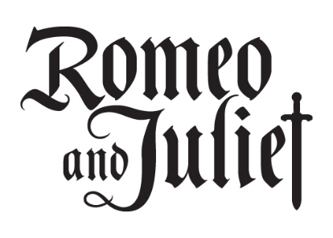

Synthesis Essay

Directions:

Answer one of the six essential questions, using the play and two informational texts.

Essential Questions/Lenses:
1. What fuels teenage relationships: true love or physical attraction?
2. What determines our lives more: fate or free will?
3. Who should we be more loyal to: lovers or family?
4. What is more important in making decisions: emotions or facts?
5. Who is responsible for the behaviors of teenagers: the minor or adults?
6. Who should we rely on to regulate the proper behavior of citizens: the government or the citizens?

Focus on supporting only one side of the essential question in your claim. Below is a suggested outline for your ideas:

- Introduction
  - As shown by Romeo and Juliet, ______________, and
_______________, __________________________________.

- Body Paragraph I—Evidence from Romeo and Juliet

- Body Paragraph II—Evidence from Informational Text #1

- Body Paragraph III—Evidence from Informational Text #2

- Conclusion

Suggestions:

- If you are at a loss of where to begin, start with what you think you can prove based off of the play; find informational texts from there.
- Follow the organizational features your learned first semester
ANT, TIQA, RRF
- Focus on showing how evidence proves your claim rather than summarizing sources
- Read the rubric (for real)

