Scottsboro Trials vs. Tom Robinson Trial
Read and discuss the article below with your lit circle. Think about how these cases could have impacted Harper Lee’s writing of To Kill a Mockingbird and what similarities you see between these cases and that of Tom Robinson. Write a Venn Diagram or a T-Chart comparing the two trials (only one person needs to write it on the back of this sheet and turn it in)…try to get as many similarities and differences as possible (Lit Circle Competition).

Based on True Stories
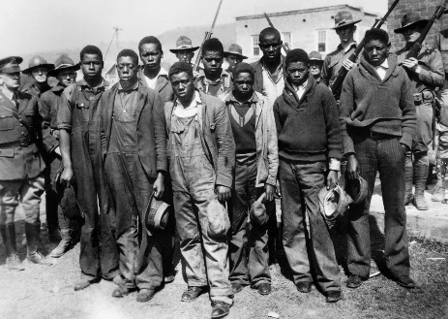
The Scottsboro Trials
In 1931, when Harper Lee was only five years old, nine black men were accused of raping two white women. The alleged incident occurred after a fight between black and white men while they were “riding the rails” looking for work. Most of the white men were thrown off the train, and when the train arrived in Paint Rock, Alabama, everyone who was left was arrested for vagrancy. The two women who were on board (one of whom was a known prostitute, the other, a minor), were also accused of violating the Mann Act, which forbade the transportation of minors across state lines for a criminal act, including prostitution. After exiting the train, the women immediately accused all nine black men of rape.

The trial of the nine black men (one of whom was only twelve years old) began twelve days after their arrest, on April 6, 1931, and lasted three days. Eight of the nine men were given death sentences, despite the fact that the defense attorney pointed out that one of the men was blind, the other too elderly and crippled to commit the crime, another underage, and that they were not even in the same rail car. Appeals would continue for nearly two years.

In November of 1932, the United States Supreme Court ordered new trials for the men, stating inadequate counsel and poor representation. In March of 1933, new trials began, and included the testimony of two doctors who refuted the likelihood that a rape occurred, Ruby Bates’s (one of the accusers) retraction of the accusation, and a harsh scrutiny of the life of Victoria Price, the other accuser. Despite the evidence, defendants Charley Weems and Hayward Patterson were again found guilty and given the death penalty. In a surprising and unfavorable turn of events, however, Judge James Horton overturned the conviction and ordered a new trial. Despite the judge’s decision, defendant Clarence Norris was also convicted and given the death sentence in a
subsequent trial. In 1935, the U.S. Supreme Court overturned the convictions stating that the defendants were not given a jury of their peers, in this case, African-Americans. The “Scottsboro Boys” as they came to be called, were tried and convicted—for a crime that never happened.

The Trial of Walter Lett
Another event that may have influenced Lee’s novel is the trial and conviction of Walter Lett. In 1933, in Monroeville, Alabama, Walter Lett was accused by Naomi Lowery of rape. With the threat of a lynching, since Lett was African-American and Lowery, white, Lett remained in protective custody. After an extremely brief trial in which Lett pled “not guilty,” he was scheduled for execution May 11, 1934. Later, his sentence of death was repealed and he was given life in prison. He died in prison in 1937 of tuberculosis.

