Name: __________________________________________________ Date: _____________

“Sinners in the Hands of an Angry God” Short Parody Assignment

Purpose: To use rhetorical appeals and devices in order to persuade/instill fear; to emulate author’s style

Directions: Now that we have read “Sinners in the Hands of an Angry God,” your job is to use the same rhetorical appeals (ethos, pathos, logos) and devices (metaphor, imagery, simile, rhetorical question), to create a parody of the text. You will follow Edwards’ overly dramatic style, identify what your sinners have done, and the wrath that they will face because of it. Lastly, you will explain how they can reach salvation. Your parody should be thorough.

Delivery: Your group of 4 will write the “sermon” and then someone (or multiple people) will deliver the sermon to the class, depending on how your group wants to divide it. Whoever delivers the sermon must deliver it with emphasis. Each group will have a “brother/sister” group who will evaluate your “sermon” for the rhetorical devices.

Parody: (noun) an imitation of the style of a particular writer, artist, or genre with deliberate exaggeration/mocking for comic effect.

Possible ideas…
- “Sinners in the Hands of an Angry Teacher”
- “Sinners in the Hands of an Angry Boyfriend/Girlfriend”
- “Sinners in the Hands of an Angry Mother/Father”
- “Sinners in the Hands of an Angry Dog/Cat/Goldfish”

Rubric:

_______ / 2 Includes two different rhetorical appeals, used appropriately, highlighted and labeled

_______ / 2 Includes at least two different rhetorical devices, used appropriately, highlighted and labeled

_______ / 2 Clearly identifies the sins that have angered your subject

_______ / 2 Clearly explains the wrath of your subject and the punishment for your sinners

_______ / 2 Explains how your sinners may redeem themselves at the end

_______ / 2 Closely follows Edward’s style, uses Standard English grammar, follows guidelines for a parody

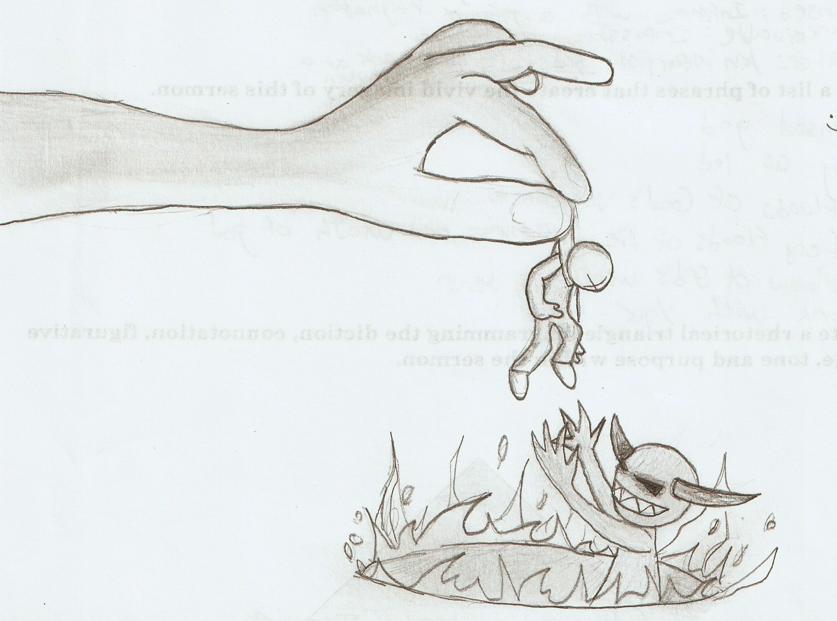
Total: _______ / 12

Team Evaluation--Group Being Evaluated: ____________________________________________________

_______ / 2 Includes two different rhetorical appeals, used appropriately, highlighted and labeled
Comments:

_______ / 2 Includes at least two different rhetorical devices, used appropriately, highlighted and labeled
Comments:

_______ / 2 Clearly identifies the sins that have angered your subject
Comments:

_______ / 2 Clearly explains the wrath of your subject and the punishment for your sinners
Comments:

_______ / 2 Explains how your sinners may redeem themselves at the end
Comments:

_______ / 2 Closely follows Edward’s style, uses Standard English grammar, follows guidelines for a parody
Comments:

Total: _______ / 12

Team Evaluation--Group Being Evaluated: ____________________________________________________

_______ / 2 Includes two different rhetorical appeals, used appropriately, highlighted and labeled
Comments:

_______ / 2 Includes at least two different rhetorical devices, used appropriately, highlighted and labeled
Comments:

_______ / 2 Clearly identifies the sins that have angered your subject
Comments:

_______ / 2 Clearly explains the wrath of your subject and the punishment for your sinners
Comments:

_______ / 2 Explains how your sinners may redeem themselves at the end
Comments:

_______ / 2 Closely follows Edward’s style, uses Standard English grammar, follows guidelines for a parody
Comments:
Total: _______ / 12

